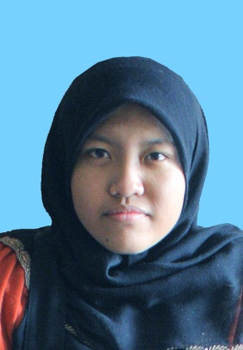**NURLIYANA BT HASSAN**

No 46, Laluan Pengkalan Sentosa 9,

Halaman Pengkalan Sentosa,

31650, Ipoh

Perak Darul Ridzuan

Phone No: 011 – 2155 5684

Email: [nur_liyanahassan@hotmail.com](mailto:nur_liyanahassan@hotmail.com)

----------------------------------------------------------------------------------------------------------------

**Personal Statement**My name is Nurliyana Bt Hassan. I am graduates from University Kuala Lumpur MIIT in Bachelor in Computer Animation. Seeking new challenge where I can fully utilize my talent and polish my skills. Having passion and willing to learn new things to improve myself to be a better artist and person in any work field.

**EDUCATION**

**2011 – 2015 University Kuala Lumpur MIIT**

BA (Hons) in Computer Animation

**2007 – 2011 University Kuala Lumpur MIIT**

Diploma in Animation

**SKILLS AND KNOWLEGDE**

**Skills;**

|  |  |
| --- | --- |
| * 2D Animation |  |
| * Storyboarding |  |
| * Illustration |  |

**Software knowledge;**

|  |  |
| --- | --- |
| * Adobe Photoshop | * Paintool Sai |
| * ToonBoom 4.5 (basic) | * Toonboom Storyboard Pro |
| * Adobe Premier | * Sony Vegas Pro (basic) |
| * Clip Paint tool |  |

**WORK EXPERIENCES**

**January 2018 – July 2018 Storyboard Artist**  
Les Copaque Production Sdn Bhd  
Work as a storyboard artist in a great story artist team producing Upin Ipin the series, Malaysian most famous 3D animation series.

**October 2016 – Current Customer Relation Officer (part time) CRO**

TGV Cinema Holdings

Work consists on assisting customers also known as Customer Services Officer

**2013 – Current Visual Artist Freelancer**

International and local fulltime and Part time Freelancer

International job mostly involving illustrations, book novel cover, character design, storyboard artist, graphic design for Indie Company and individuals.

**March – Mei 2016 Graphic Designer (Freelancer)**

Pristine Solutions Sdn Bhd

Designing a brochure and Pamphlet for the company to promote their cosmetic and healthy drink product supervised by the founder of the company itself.

**Feb – June 2015 Lecturer for 2D Principles of Animation**

University Kuala Lumpur MIIT, Kuala Lumpur

Part time lecturer, teaching Principles in animation for Diploma in Animation students, semester 1. Focusing more on 2D animation.

**July 2014 – July 2015 Research Assistant and Concept Design Artist**

University Kuala Lumpur MIIT, Kuala Lumpur

Researching and collecting data for the research project title “Autism Movement Guidelines for Animators” under Skim Grant Pendidikan Mara 2015 (SGPM 2015) supervised and team leader by En. Mohammad Zaky Khairuddin, a former senior lecturer of Animation Department in Unikl MIIT.

**April – June 2014 PTS Publishing Sdn Bhd**

Colorist

Freelancer Colorist for “Hari Bantai”, a children storybook by one of the company official storywriter.

**Jan – Jun 2011 Funcel Animation Studio, Kelana Jaya, Kuala Lumpur**

**2D Animator, Layout Design, Character Design**

Worked as an industrial trainee student, in a tight schedule which that the company needs to produce at least 2 episodes and sometime 2 series in a month with a small group of employees and sometimes under pressure.

**REFERENCES**

|  |  |
| --- | --- |
| Mdm. Nurul Lina  Senior Lecturer of Computer Animation,  Creative Multimedia Department  University Kuala Lumpur MIIT  52300 Kuala Lumpur,  Malaysia  Tel : 012 2732134 | **En. Muhammad Zaky Bin Khairuddin** Senior Lecturer of Computer Animation,  Creative Multimedia Department  University Kuala Lumpur MIIT  52300 Kuala Lumpur, Malaysia  Tel: 03 – 2175 4290 |